Parish Office the Parish Offices are working as usual but must remain closed to the public. Any queries by email will still be answered. There will be someone to answer the phone in person on a Friday morning only in St Peter’s. Our contact details are below. If you need a priest urgently, please phone St Peter’s Church on 01285 652087

2021 The Year of St Joseph It is 150 years since Blessed Pius IX declared St Joseph the patron saint of the Universal Church. To mark this important anniversary, Pope Francis has declared a Year of St Joseph, starting on the Solemnity of the Immaculate Conception of his wife. Special indulgences are granted to the faithful throughout the year under the usual conditions (recent Holy Communion and Confession and prayers for the Pope’s intentions). More detail of the Year’s special celebrations will be published later.
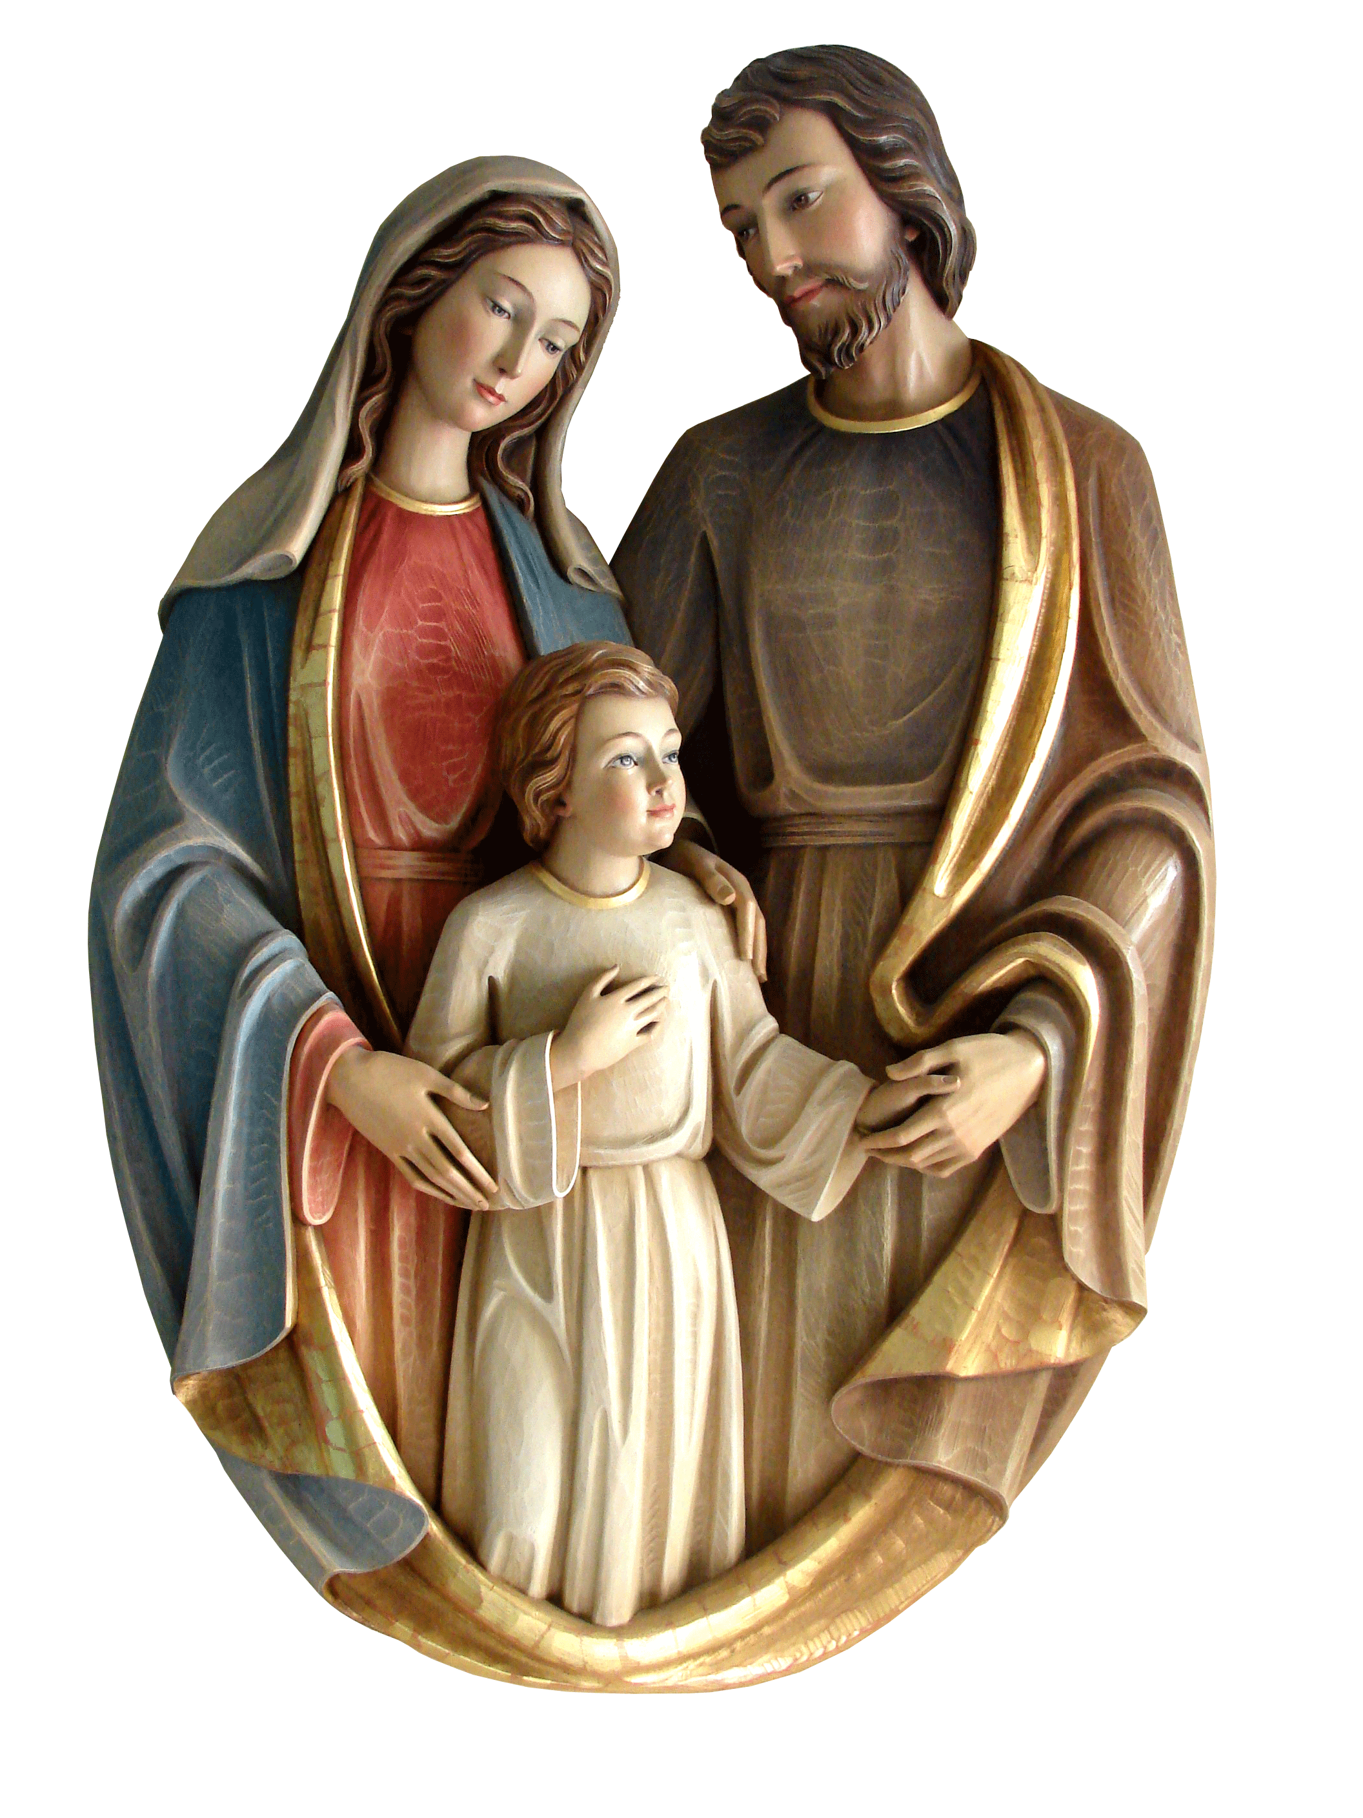
Holy Family prayer. At a time when we were unable to spend the Christmas Season with our families; let us continue to remember and pray to the Holy Family especially at this time, for them and those on their own.

Because of That Virus, the following measures have been put in place:
- No baskets are passed around at the Offertory, but are at the back of the church to put your offering and charity donations on leaving the church
- No hymn books (because there’s no singing), Mass cards etc. at present. Use a bulletin and take it home!!!!!

We have just started England’s Third National Lockdown of this Pandamic!!
Please remember: -
- Members of our families and Parishes, together with those throughout the district, who have died in the past year;
- Those who have been or who are sick with Covid 19
- Those have had problems of any sort.
- The elderly, the vulnerable and all, who are shielding.
- All front line workers and carers, especially in our nursing homes and the NHS

if you need any help please contact the Parish Office and we will see how we can help. May God Bless you and keep us all safe in His care.’ God Bless, Fr Philip

CONTACT US
Parish Priest - Fr Philip Thomas - Parish Administrator–Elaine Wright
St Peter’s Catholic Church,
Telephone 01285 652087 / Website: www.stpeterscirencester.org
Email Parish Office: cirencester.stpeter@cliftondiocese.com
Email Fr Philip Thomas: philip.thomas@cliftondiocese.com
St Michael’s Catholic Church
Telephone: 01666 502367 / Website: www.stmichaelstetbury.org.uk
Email Parish Office: tetbury.stmichael@cliftondiocese.com
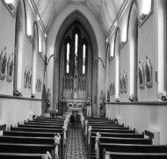  St Peter’s RC Church  7 St Peter’s Road  Cirencester  Gloucestershire  GL7 1RE | 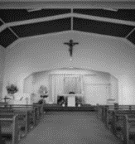  St Michael’s RC Church,  Silver Street  Tetbury  Gloucestershire  GL8 8DH
CHRISTMAS III BAPTISM OF CHRIST (YEAR B)
WORSHIP THIS WEEK
NO SATURDAY VIGIL MASS TILL AFTER NATIONAL LOCKDOWN
Jan 10th Jan 9.00am Mass in St Michael’s
11.00am Mass in St Peter’s (Pro Populis)
Mon 11th Jan Feria in Ordinary Week 1
No Public Mass
Tue 12th Jan St Aelred of Rievaulx, National Memorial
9.30am Mass in St Peter’s
6.00pm Traditional Latin Mass in St Peter’s
Wed 13th Jan St Hilary of Poitiers
10.00am Mass in St Michael’s
Thu 14th Jan Feria
9.30am Mass in St Peter’s
Fri 15th Jan Feria
9.30am Mass in St Peter’s
12.00 Noon Traditional Latin Mass in St Peter’s
Sat 16th Jan Our Lady on Saturday
10.00am Mass in St Michael’s

SUNDAY II ‘through the year’ (YEAR B)
Sun 17th Jan 9.00am Mass in St Michael’s
11.00am Mass in St Peter’s

CONFESSIONS BY APPOINTMENT ONLY AT PRESENT
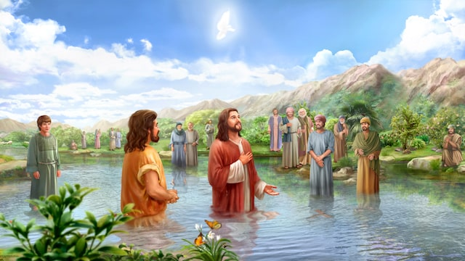

Thank you for your co-operation & unDerstanDING in these difficult times AND WE WISH YOU A blessed SUNDAY

if you need any help please contact the Parish Office and we will see how we can help. May God Bless you and keep us all safe in His care.’ God Bless, Fr Philip
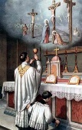
We intercede: -
- For the Universal Church: that all the Baptised will be inspired by the Holy Spirit to bear Christ united witness.
- For those who do not yet know Jesus as the Father’s Beloved Son: that they may open their hearts and come to believe in the Good News.
- For ourselves, our parish and deanery: that we may have a true spirit of humility and evangelisation in our preaching, prayer and example, pointing always towards the Living Christ, like John the Baptiser.
- For the Diocese of Clifton and our two parishes: that we will work together in promoting that God is our Father and Saviour.
- For the sick, the lonely, the housebound and the vulnerable: that, in the midst of their suffering, they will experience the loving arms of Christ.
- For all those affected by the Covid-19 epidemic throughout the world: that they may recover quickly and completely. We remember in particular the doctors, nurses, careers and all who are working so unceasingly to assist those in most danger: that they may be safe.
- For those departed this life: that God, who called each of us by name, may call all the departed to His Heavenly Kingdom.

THOUGHT FOR THE WEEK The Incarnate Son of God is perfect in every way. He has no need to be baptised for the remission of sins, as John the Baptist says. Instead, He freely chooses to do so. Firstly, He associates Himself with sinful humanity in an act of solidarity. Secondly, He hallows the waters and so points towards the hallowing of all creation in association with the future redemption of humanity. Thus, the Lord’s Baptism becomes for us a twofold invitation!! Firstly, for us to associate ourselves with Jesus Christ in this world before friend and foe alike. Secondly, for us be part of the hallowing and redemption of material creation around us. This will have ecological and economic consequences, which may spill over into political action.

THE CRIB: By ancient English Tradition, the Crib will come down on Candlemas, 40 days after Christmas Day.

ORDINARY TIME Liturgically, we are now entering the first part of Ordinary Time up until Ash Wednesday. Many think that ‘Ordinary Time’ means nothing exciting happens. This is not what the Church thinks. This Counted Time, like Ordinal Numbers, so why not use these weeks to ponder over own faith and how we can make it stronger all the while by preparing for Ash Wednesday and the beginning of Lent.

FUTURE DATES:
2nd February 2021 The Presentation of the Lord
17th February 2021 Ash Wednesday
4th April 2021 First Sunday of Easter - The Resurrection of the Lord
MASS TEXTS
Entrance Antiphon: After the Lord was baptized, the heavens were opened, and the Spirit descended upon him like a dove, and the voice of the Father thundered:
This is my beloved Son with him I am well pleased.
Sprinkling with Holy Water – The ‘Asperges’
Gloria Glory to God in the highest, and on earth peace to people of good will. We praise you, we bless you, we adore you, we glorify you, we give you thanks for your great glory, Lord God, heavenly King, O God, almighty Father. Lord Jesus Christ, Only Begotten Son, Lord God, Lamb of God, Son of the Father, you take away the sins of the world, have mercy on us; you take away the sins of the world, receive our prayer; you are seated at the right hand of the Father, have mercy on us. For you alone are the Holy One, you alone are the Lord, you alone are the Most-High, Jesus Christ, with the Holy Spirit, in the glory of God the Father. Amen.
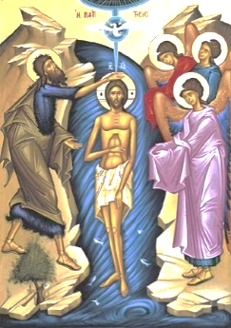
First Reading: Isaiah 55: 1-11
Responsorial Psalm. With joy you will draw water from the wells of salvation
Second Reading I John 5: 1-9
Gospel Acclamation Alleluia, alleluia! John saw Jesus coming towards him and said: This is the Lamb of God who takes away the sin of the world. Alleluia!
Gospel Mark 1: 7-11
Apostles Creed: I believe in God the Father Almighty, Creator of heaven and earth and in Jesus Christ, His only Son, our Lord, Who was conceived by the Holy Spirit, born of the Virgin Mary, suffered under Pontius Pilate, was crucified, died and was buried; He descended into hell; on the third day He rose again from the dead; He ascended into heaven and is seated at the right hand of God the Father Almighty; from there He will come and judge the living and the dead. I believe in the Holy Spirit, the Holy Catholic Church, the communion of saints, the forgiveness of sins, the resurrection of the body and life everlasting. Amen.
Communion Antiphon: Behold the One of whom John said: I have seen and testified that this is the Son of God
Act of Spiritual Communion Lord Jesus, I believe that You are present in the Holy Sacrament of the altar. I love You above all things, and I passionately desire to receive You into my soul. Since I do not now receive You sacramentally, come spiritually into my soul, so that I may unite myself wholly to You, now and forever. Amen.

Prayer to St Michael, recommended by the Holy Father Holy Michael Archangel, defend us in the day of battle. Be our safeguard against the wickedness and snares of the devil. May God rebuke him, we humbly pray, and do thou, Prince of the heavenly host, by the power of God thrust down to hell Satan and all wicked spirits, who wander through the world for the ruin of souls. Amen.

